13 October 2023

The General Manager

Strathfield Municipal Council

65 Homebush Road,

STRATHFIELD NSW 2135

Dear General Manager,

**Strathfield to Hornsby RAIL CLOSEDOWN**

**Saturday 28 and Sunday 29 October 2023**

**Background**

I wish to advise that Sydney Trains is planning the closure of the Northern Line between Strathfield and Hornsby on **Saturday 28 and Sunday 29 October 2023**. During this period, buses will replace train services for the extent of the closure.

The work is part of the coordinated possession regime planned to minimise the overall impact on passengers. The strategy allows for a cyclical maintenance/capital works program that maximizes the resource commitment to the applicable line closure while minimising the frequency of the possession.

This closure is planned to occur on the following next occasion:

|  |  |
| --- | --- |
| **No** | **Dates** |
| 1 | 9 – 10 March 2024 |

**Council Advice**

The bus routes operating during the closure are fully detailed in the attachment. This correspondence has been provided to ensure Council has timely advice of the work and to further reinforce Sydney Trains’ commitment to improved communications with affected Authority bodies.

Should you require further information or require the attendance of Sydney Trains officers at your offices, I would be pleased to arrange the same. Should you require any further information on the above, please call the undersigned on telephone number 0456 995 349

Yours faithfully,

Iulia Carp

Event and Trackwork Officer

Sydney Trains

**OVERALL BUSSING STRATEGY**

This Contract is for the provision of Temporary Bus Services to replace Sydney Trains Services on the Main North Lines that result from possession works on the weekend of **Saturday 28 and Sunday 29 October 2023**, affecting stations between **Strathfield to Hornsby.**

The Temporary Bus Service routes operating are:

1. **Route 1T9** Strathfield, North Strathfield, Concord West, then express to Eastwood, Epping, then express to Hornsby and return
2. **Route 1AT9** Strathfield, North Strathfield, Concord West, then express to Eastwood, Eppingand return
3. **Route 2T9** Strathfield, all stations to West Ryde, then Eastwood, Epping and return
4. **Route 2AT9** Strathfield, then all stations to West Ryde and return
5. **Route 82T9** Hornsby, then all stations to Epping and return
6. **Route 85T9** West Ryde, Denistone, then Eastwood and return (Denistone Shuttle)

**Accessible Service (DDA) Requirements**

All Service trips must be DDA compliant, in each direction, must be wheelchair accessible, on all days. These Service departures are to be highlighted in the compliant Timetable.

|  |  |  |  |
| --- | --- | --- | --- |
| **INDICATIVE REGULATORY SIGNAGE DESCRIPTIONS** | | | |
| **Station** | | **Up Direction**  **(To Central/Strathfield**) | **Down Direction**  **(To Hornsby/Newcastle)** |
| The following table briefly describes the scope of service changes between Central and Newcastle Interchange. The attached table specifies the indicative service requirements for all stations throughout the closedown period. | | | |
| Strathfield | Replace existing ‘No Stopping’ in front of R.I.C. depot within Strathfield Interchange on station kerb with bus zone. Create bus zones in Everton Road – One on station side from the end of the taxi rank back to the park approximately 80 meters, and one on the opposite side of the road at the corner for 20 meters.  Create bus zones in Everton Road – One on station side from the end of the taxi rank back to the park approximately 80 meters, and one on the opposite side of the road at the corner for 20 meters.  Replace entire timed angle parking in Everton Road between Mosely Street and Leicester Street roundabouts (opposite station and bus stands) with a bus zone. Also cover all parking metres and install cones along kerb. ***Traffic Warden to assist with cones to ensure cars do not park overnight.*** | | |
| Rhodes | Create bus zone in ½ parking for 2 car spaces. | | Create bus zone at bus shelter – (currently bus stop Mon – Fri.) **Extend bus zone at bus shelter towards South, replacing the entire 1 hour parking zone. (Due to the road works, the bus shelter will be unavailable this weekend)** |
| Meadowbank | Nil | | Create bus zone in Railway Road along station side, between Banks St and Constitution Road replacing 30 minutes parking zone. Also install cones along kerb. *Traffic Warden to assist with cones to ensure cars do not park overnight.* |
| Beecroft | Nil | | Replace existing 1 hour parking School Bus Zone in Wongala Crescent with Bus Zone for 30 metres opposite station, outside the carpark. |
| Pennant Hills | Create bus zone in ½ parking for 2 car spaces. | | Replace time limited Bus Zone Yarrara Rd between Pennant Hills Dry Cleaners and Bakery with Bus Zone. |
| Epping | Create bus zone in ½ parking for 5 car spaces and set up cones, station side of Beecroft Road, either side of overhead pedestrian bridge  Create new bus zone on the eastern side of Ray Road by converting existing ‘no parking’ and half of the existing ‘no stopping’ zones between Carlingford Road and Edensor Street. | | Nil |
| Hornsby | Replace and create 260 metres of angled parking on east kerb of Jersey Road with bus zone signage for layover area from the roundabout Commuter Car Park at Coronation Road to Jersey Rd Bridge.​  Create new bus zone in George Street, on the east side (directly opposite the Down Direction bus zone) for approximately 80 metres for set down only.(In front of CP Building) | | Replace 200 metres of kerbside parking on west kerb of Jersey Road with bus zone signage for layover area from the roundabout on Coronation Road to the front of Hardware & General.​  Extend bus zone in George Street, on the west side in indented bus bay for approximately 25 metres as additional space up to and including Taxi Stand.​ |
| **Taxi Zone Set Up Hornsby – Station St;** Relocation of exiting Taxi zone Station side to shop side as per picture below;   * Set up of Taxi Zone area on Station Street should be relocated to across the street in the existing 1/4 P timed parking zone as per the map below. * Set Up of 25 meters of Bus Zone Parking Area for bus lay over as per the map below.   cid:1620bc22-59db-4079-bca2-18b5ceee1af2 | | |
| Hornsby Commuter Car Park 1 - Right hand side of George St adjacent railway corridor | Secure and ensure the 3 x Disabled Carpark spots @ George St Hornsby Station Parking 1 adjacent to rail line for additional Marquee and bus zone arranged in for customer going South of Wyong (traffic Management arrangements)  Hornsby – George St carpark – Southern end (top carpark section after Peats Ferry Rd intersection)  (Opposite Westfield)  6 cones - Occupy 6x spaces (3 Disable spaces, 3 diagonals lined spaces) on rail corridor side in corner closest to overhead walk bridge & in front of High Voltage transformer boxes.  1x Right Arrowed BLANK sign for corner to cover Disable.  **See Map Below:** | | |
| Gosford | Create bus zone in the “Kiss N Ride” area in Showground Road. | | Nil |
| Broadmeadow | Create bus zone south west side of Graham Rd outside the station for 250mtrs (towards Lambton Rd ) for Standby/layover busses | | |
| Hamilton | * Replace existing 1 hour parking outside the Sydney Junction Hotel on the western side of Beaumont Street with Bus Zone. * Replace existing 2 hour parking station side of Fern St (opposite Yoo, east of Beaumont Street intersection with Bus Zone (approximately 100 meters). | | |
| Newcastle | Create bus zone south side of King Street between Steel St and National Park Road, approximately 200mtrs for Standby/layover buses | | |

**HORNSBY**

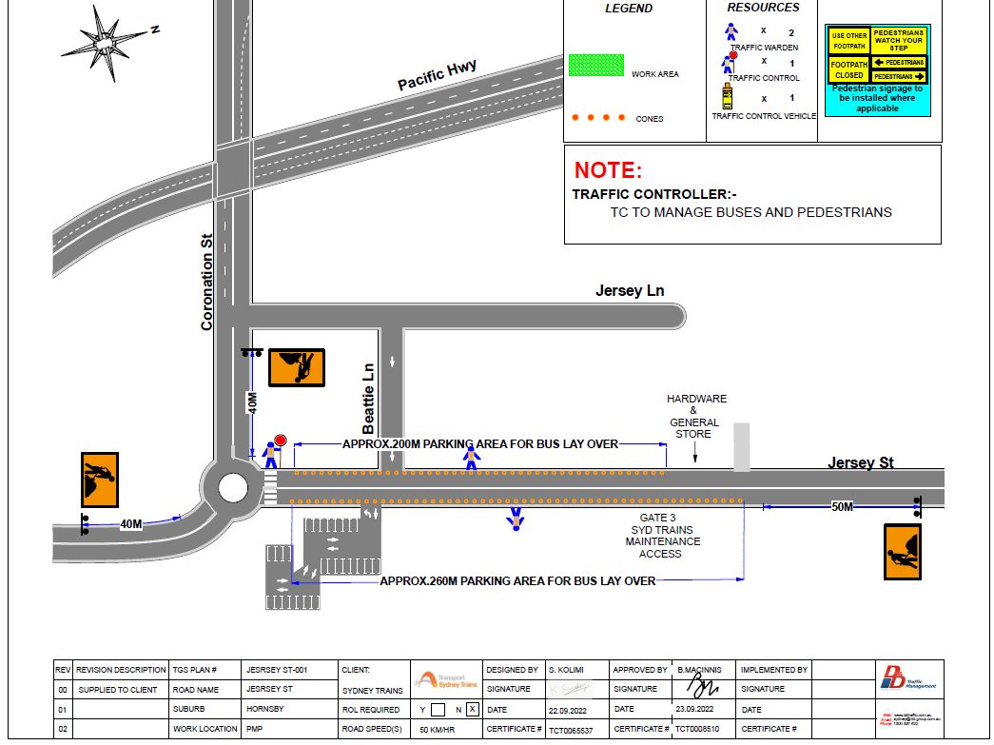

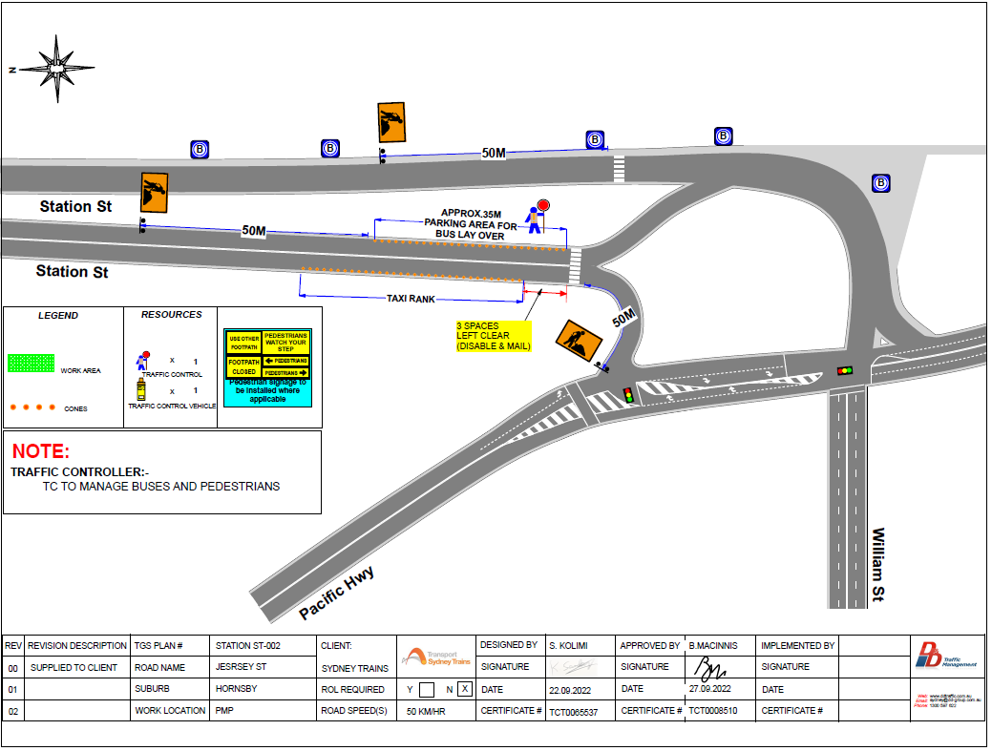

**Hornsby Station Car Park 1 George St**

